**JMeter Example_4**

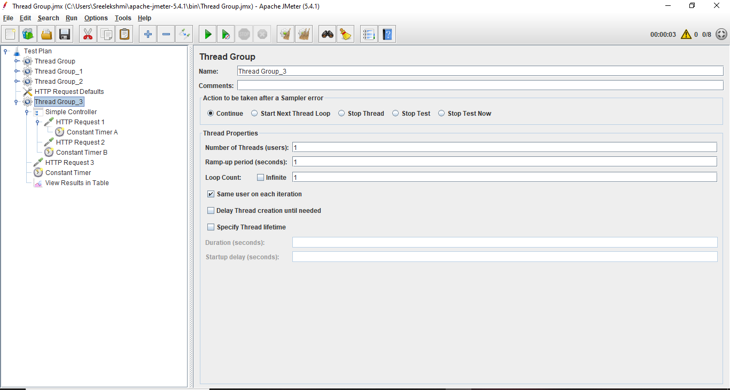After adding Thread Group

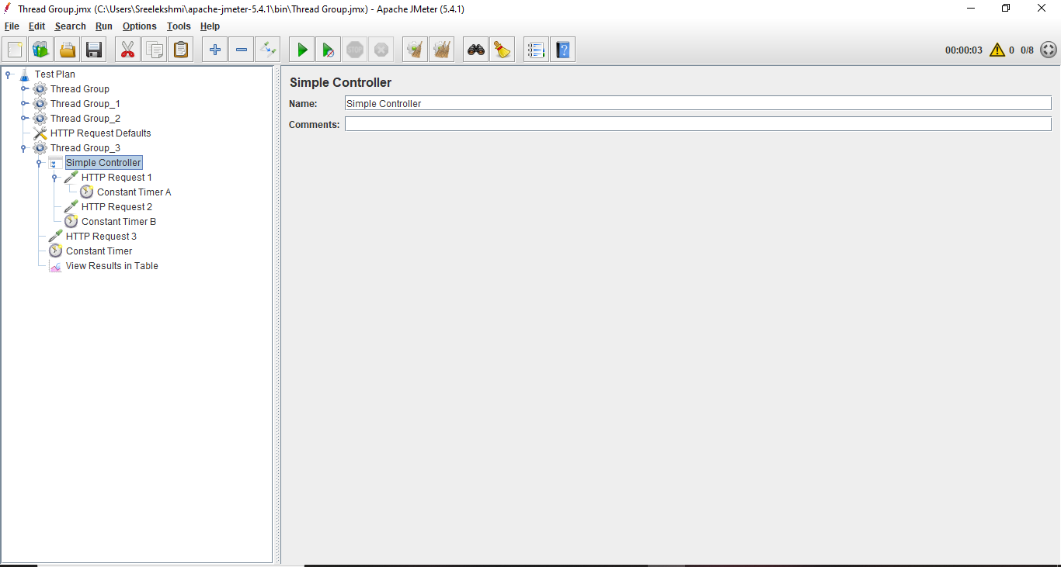**After adding the Logic Controller**

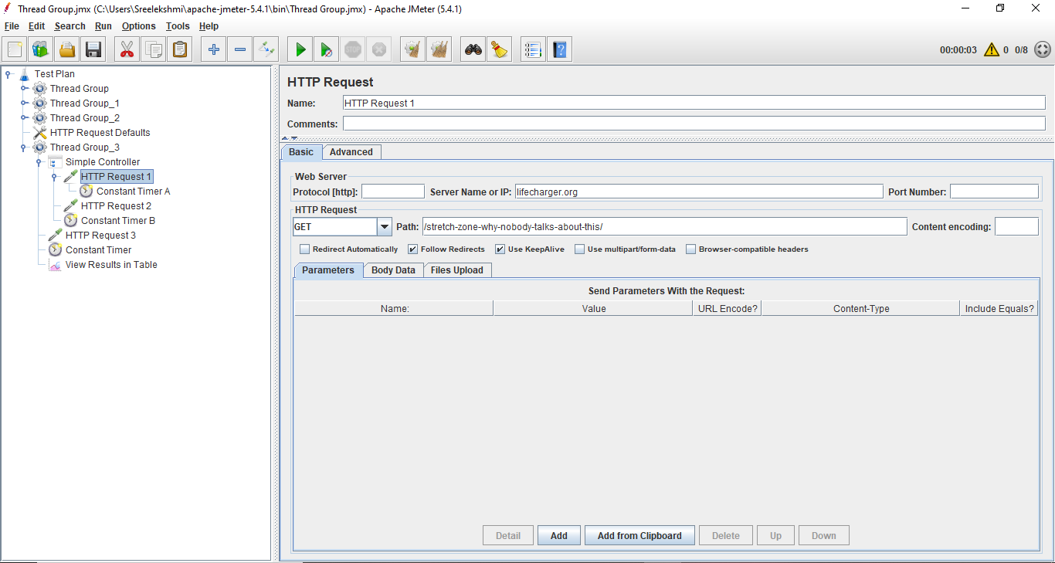After adding First Sampler HTTP Request 1

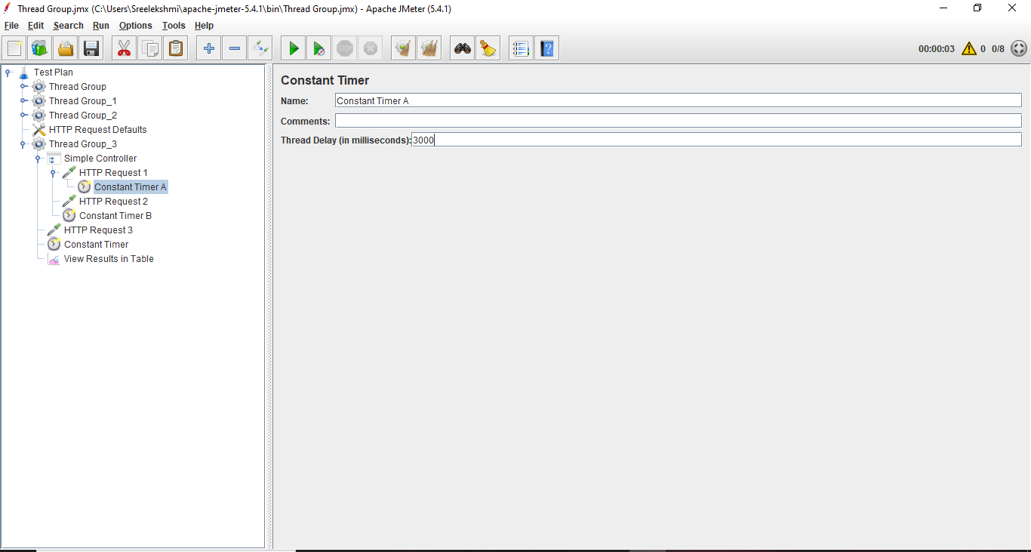First Constant Timer

After adding the 2nd Sampler HTTP Request 2

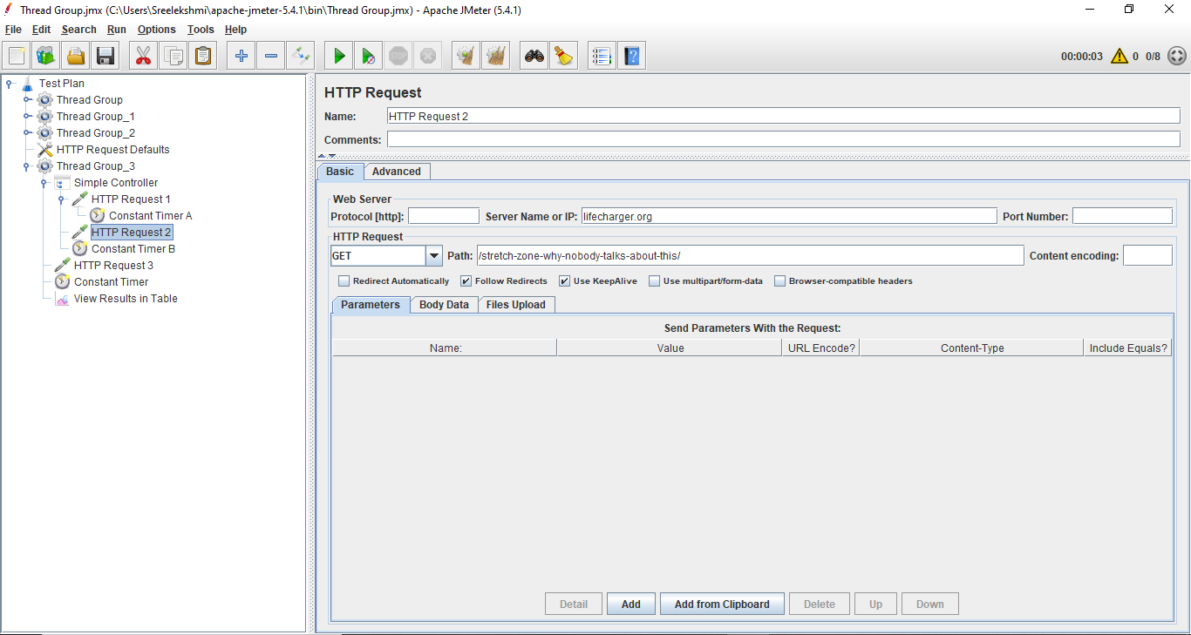

Second Constant Timer

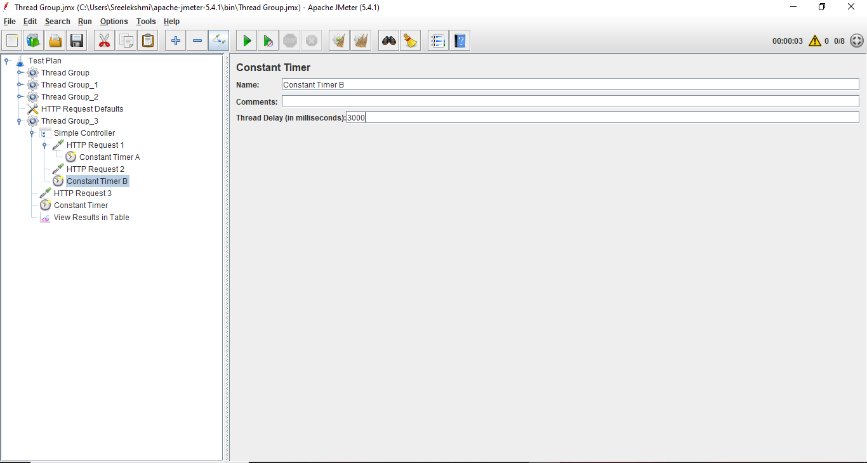

After adding the Third HTTP Request 3

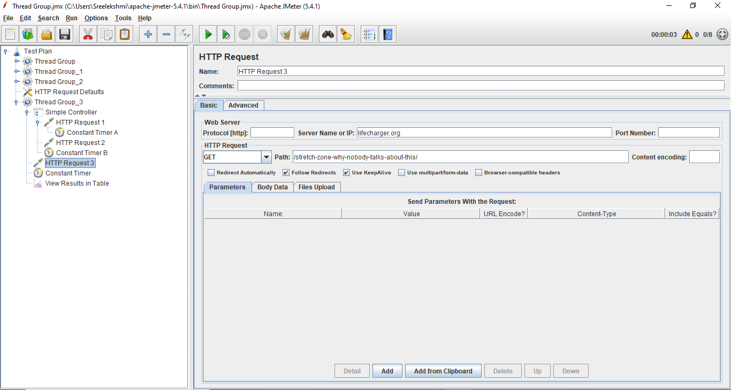

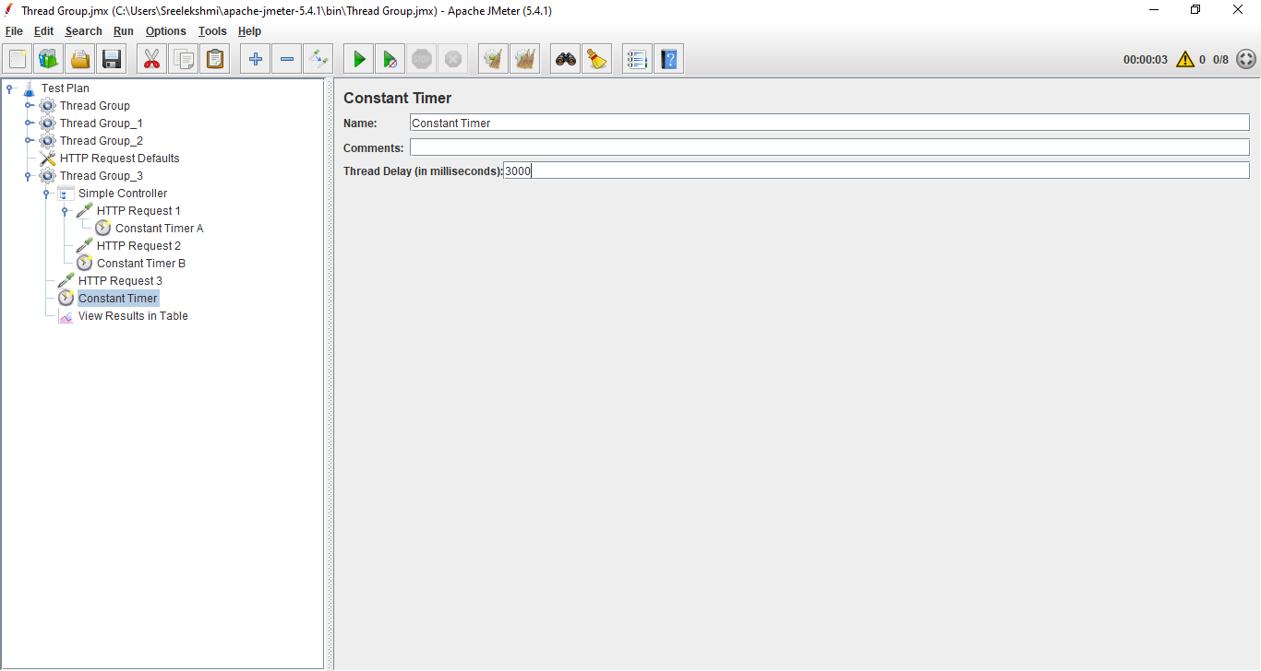Third Constant Timer

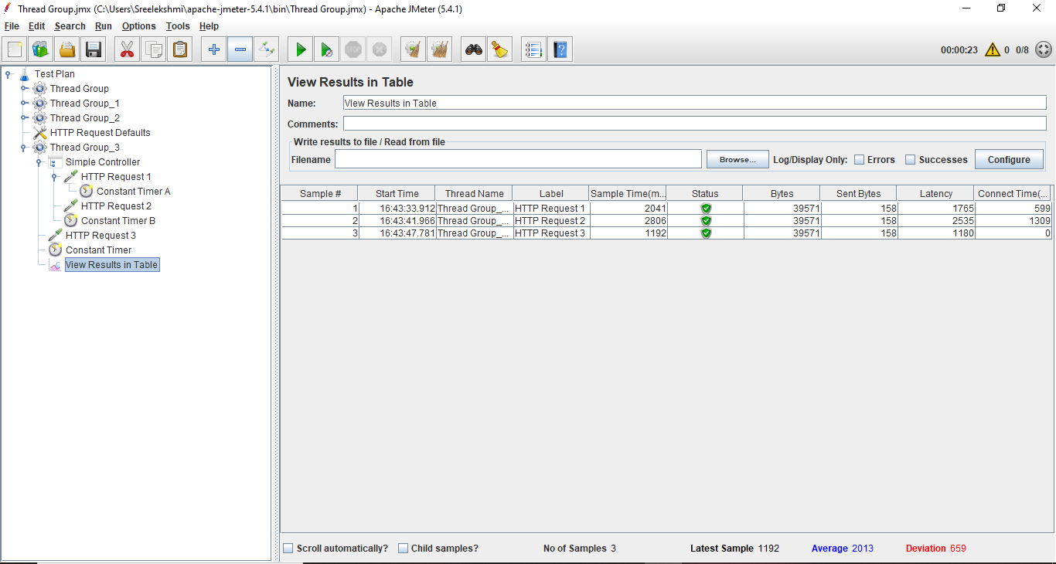Result of the HTTP Request in the Table format

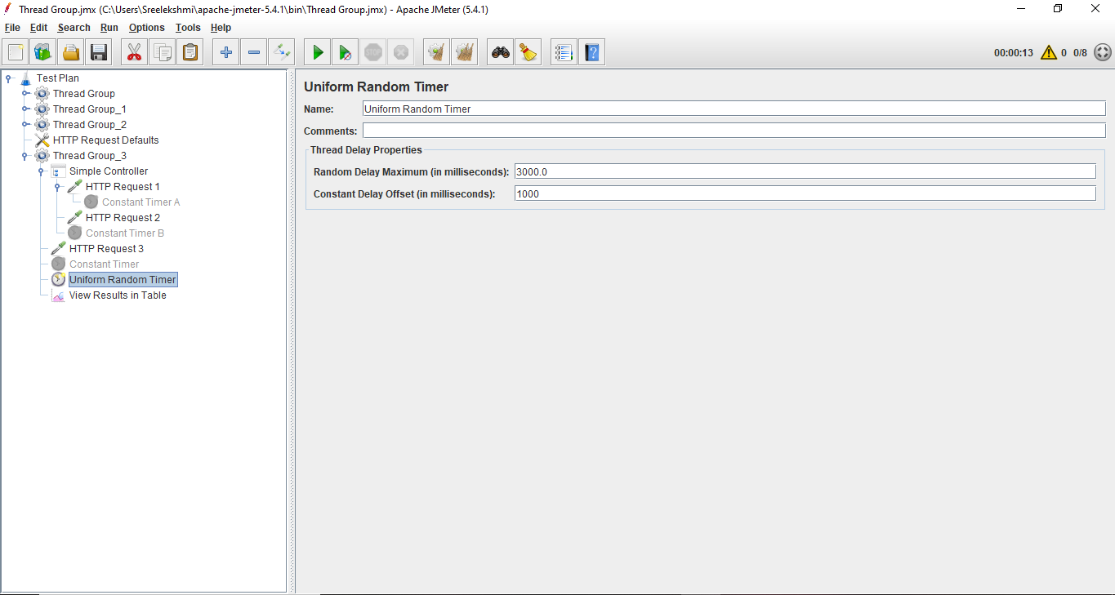After disable all the Constant Timer and added the Uniform Random Timer

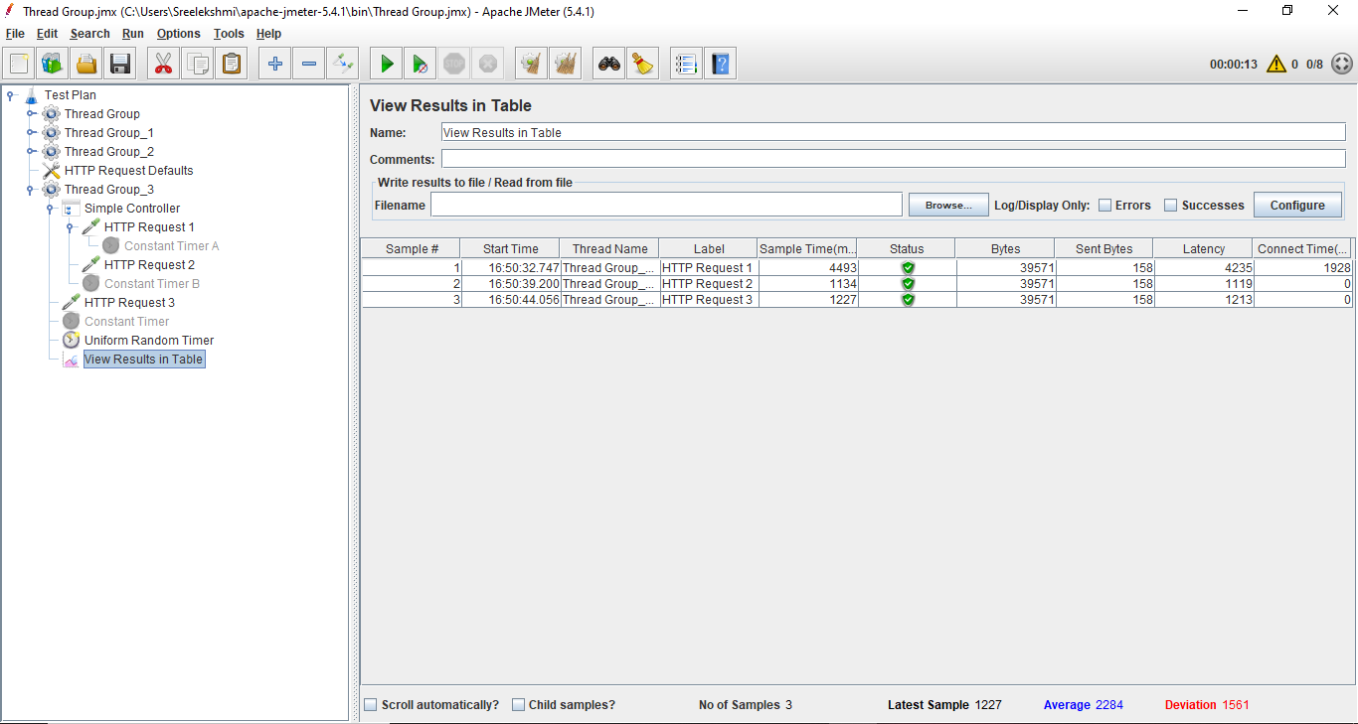Result After adding Uniform Random Timer